**SCREEN SHOTS**

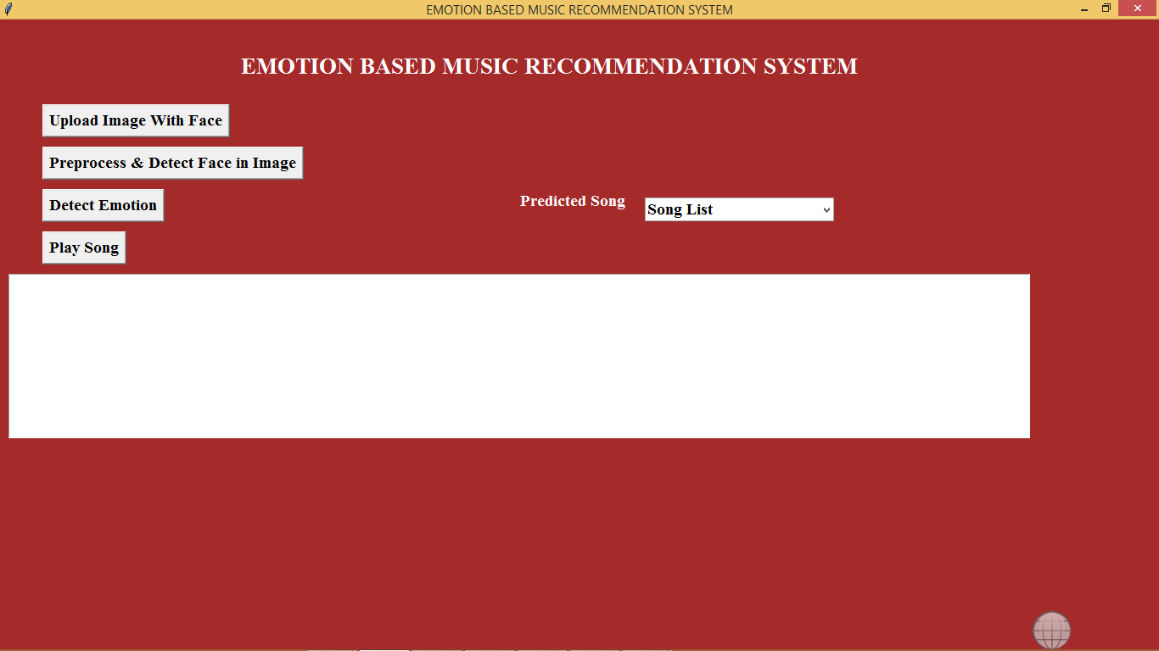

In above screen click on ‘Upload Image With Face’ button to upload image

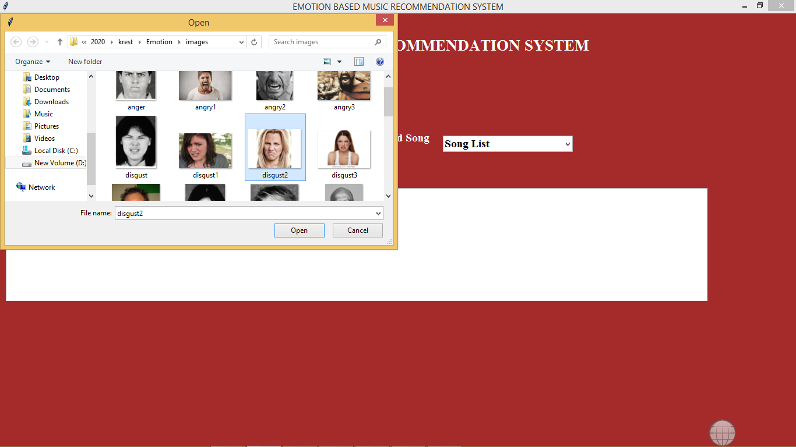

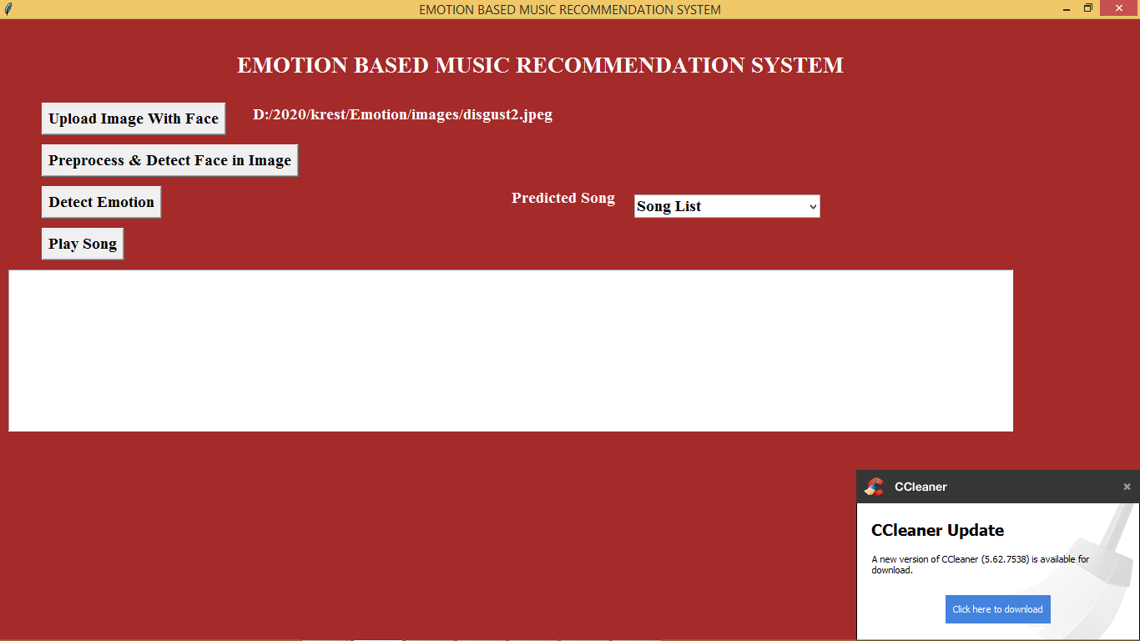

In above screen i am selecting one ‘disgust’ image. Now click on ‘Pre-process & Detect Face In Image’ button to perform pre-processing and to extract face from images

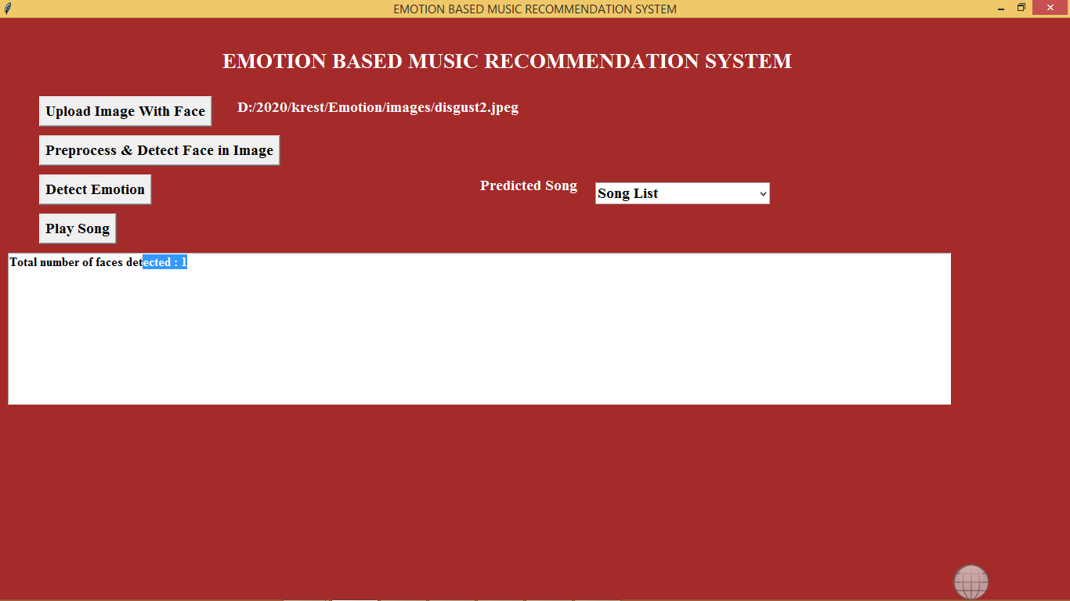

In above screen we can see in uploaded image one face is detected. Now click on Detect Emotion button to detect emotion

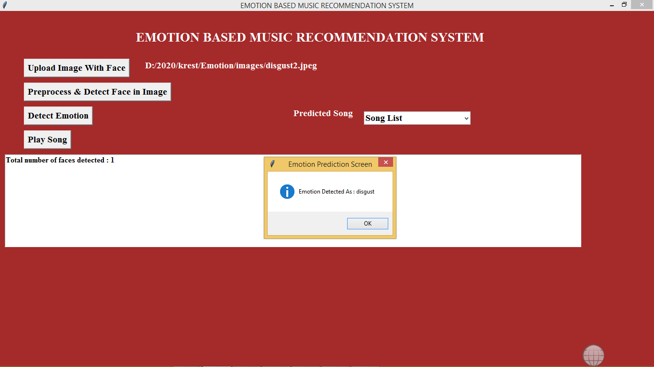

In above screen we can see emotion disgust is detected and now click on drop down arrow link to get all disgust songs list

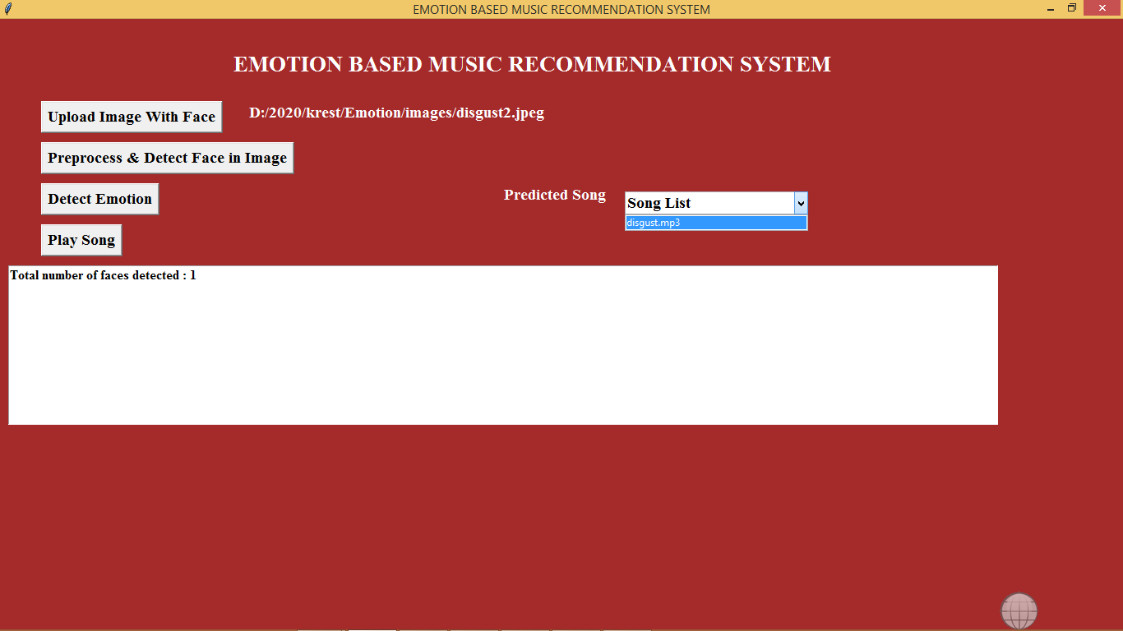

In drop down box we can see ‘disgust.mp3’ songs is showing, select that song and click on ‘Play Song’ button to play song

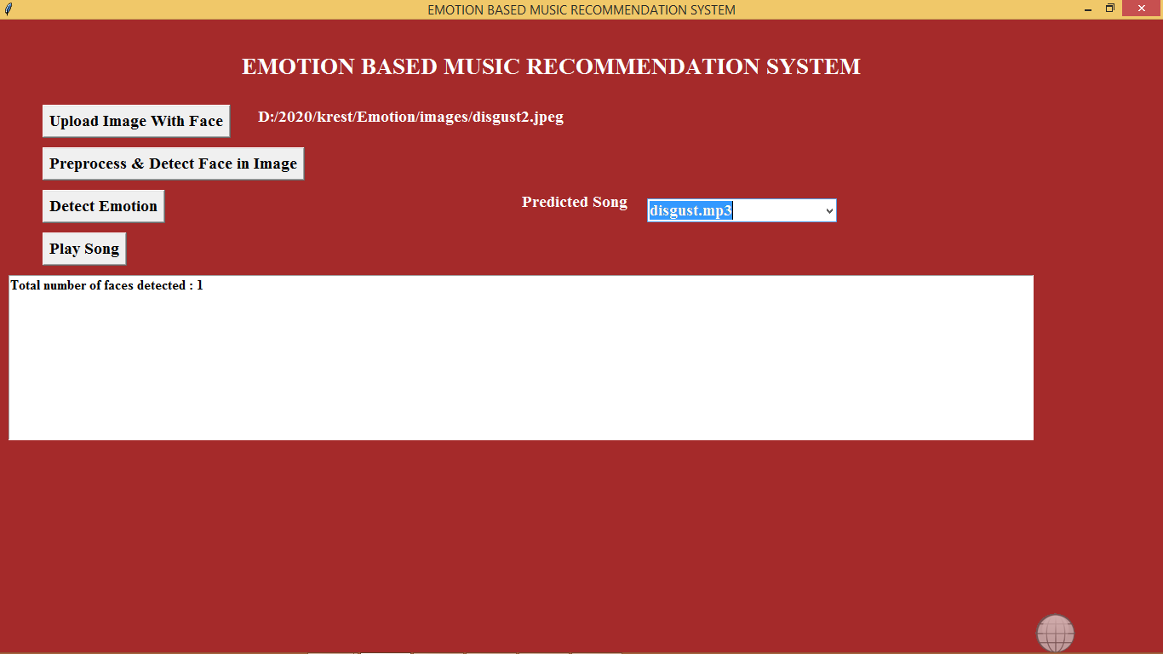

If your system has audio driver then u can hear song.

Note: no technologies can detect 100% emotion from images but this project can detect upto 90%